Responsive Design Test

1. Smart Phone

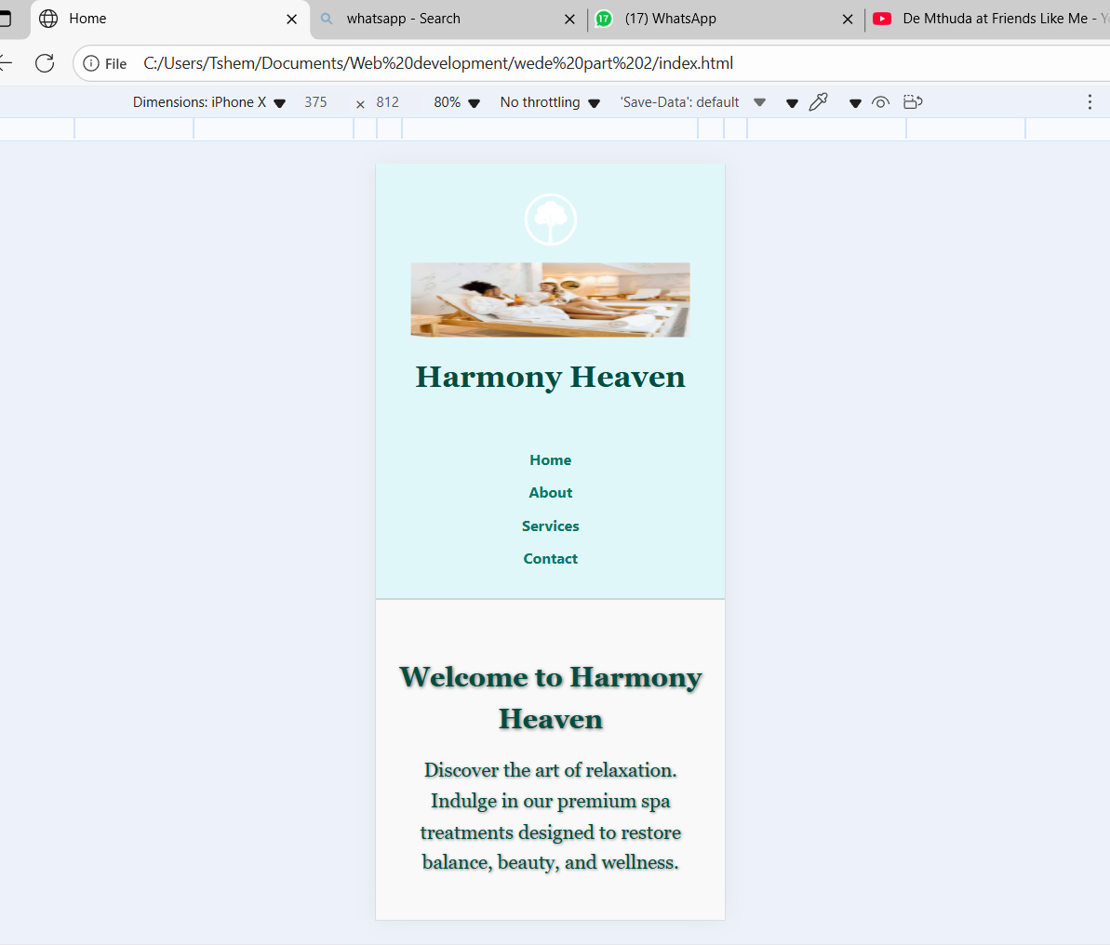

1. Tablet

1. Desktop/Laptop

